**Comparison between 2D PEFIT moving point and moving load system**

**Objective:**

1. Verifying model by running moving load and moving point system and checking their dynamic responses.
2. Decreasing total computational time by using coarser mesh size.

**Note:** In the report, only measuring point at base bottom is picked for analysis and comparison, results of other measuring points at base top/middle is documented in appendix, where measuring point at base top can be referred to figure 4.

1. **Comparison between moving load and moving point**
   1. **Input info and loading condition**

The model size and input info is displayed in table 1 and soft loading condition is shown in figure 1.

Table 1 Input parameters

|  |  |  |  |  |  |  |  |  |
| --- | --- | --- | --- | --- | --- | --- | --- | --- |
| Model size | Mesh size | dt | Loading length | Permeability | Time step for output file | load moves forward each time step | Absorbing factor | Total calculated time (s) |
| 800 x 89 (3+6+80) | 0.5 x 0.5 | 1E-06 | 8 in | low | 1E-03 | 2 | 0.00045 | 0.4 |

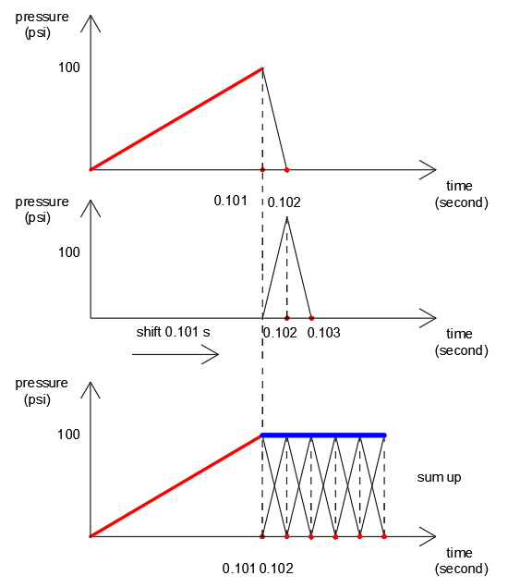

Fig.1 Loading condition

* 1. **Comparison between moving point and moving load results**

Dynamic responses of moving point/load systems at base bottom are compared in figure 2. Figure 2 a presents the total vertical stress of both systems, where curves match up well. Figure 2b shows the comparison of pore pressure at base bottom, as can be seen that two curves basically math up, but differences are noticed at some parts circled out in the plot.

|  |  |
| --- | --- |
|  |  |
| (a) Total vertical stress (base bottom) | (b) Pore pressure (base bottom) |

Fig.2 Comparison between dynamic responses of moving load and moving point system

To further check the difference between moving load and moving point, dynamic responses (total vertical stress, pore pressure) of moving load matrices are subtracted from those of moving point system, and the **absolute** value of differences were presented in figure 3. As can be seen that difference of vertical stress shows in figure 3 a is less than that of pore pressure plots in figure 3b. Moreover, the soft-landing process has better effect on vertical stress than pore pressure, where from figure 3 b oscillation of curve at the beginning (distance -200 to -100) is larger than that in figure 3 a.

|  |  |
| --- | --- |
|  |  |
| (a) Difference stress (base bottom) | (b) Difference pore pressure (base bottom) |

Fig.3 Absolute difference between dynamic responses of moving load (ML) and moving point (MP) system, total vertical stress (a) and pore pressure (b)

* 1. **Source causing difference between moving point/load systems**

The difference possibly comes from absorbing boundary which is not able to absorb waves for 100%. Concretely, in moving point system (figure 4a), the load is fixed at the center, 400 inches away from left/right absorbing boundary, while for moving load system (figure 4b), where load at beginning is 200 inches away from left boundary, at the end arrives at 200 inches away from right boundary. The difference of moving point/load system comes from their different relative distance between load position and absorbing boundary.

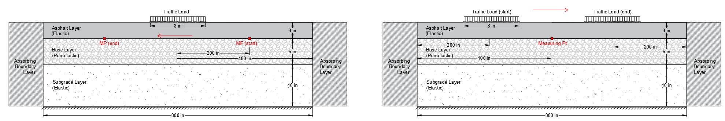

**(a)**



**(b)**

Fig.4 Comparison between moving point (a) and moving load method (b)

To substantiate the hypothesis, a larger model with 1600 inches width is tested for both moving point and moving load systems. The data of vertical stresses (figure 5a) match up well, and results of pore pressure from two systems getting closer. The differences are quantitatively plotted in figure 5c and d, by comparing these plots with data in figure 3 a and b, the influence of absorbing effect on dynamic responses of two systems are examined. As larger model helps attenuating wave energy which compensates the effect of absorbing boundary. Therefore, differences plotted from larger model (figure 5 b and d) are less than those from normal size model (figure 3 a and b).

|  |  |
| --- | --- |
|  |  |
| (a) Total vertical stress (base bottom) | (b) Pore pressure (base bottom) |
|  |  |
|  |  |
| (c) Difference stress (base bottom) | (d) Difference pore pressure (base bottom) |

Fig.5 Dynamic responses (a), (b) and their differences (c), (d)

In addition, by testing different absorbing parameter, it is found that absorbing boundary works better at absorbing stress waves than pore pressure, which explains why difference in figure 3b is overall greater than that in figure 3a.

* 1. **Partial conclusion**

1. By comparing dynamic responses, both moving point/load systems work properly under soft-landing condition, and dynamic responses from both system math up with each other.
2. Absorbing boundary has a better effect on absorbing stress waves than pore pressure.
3. **Computational time for model with different types of mesh sized**

In section 1, though both moving point/load system are verified by comparing the dynamic responses, the total computational time for running a single model is about 8.5 hours. If the same model is kept using for future study, it would be computational inefficient and may lose flexibility when considering various scenarios such as pavement with joint. Therefore, to make model run with less computational time, efforts were made on testing coarser mesh size and examining their accuracy by comparing dynamic responses with fine mesh (0.5 x 0.5, used in models in section 1).

In table 2, models with different mesh sizes are calculated and the total computational time for each case is counted.

Table 2. Comparison between case 1, 2 and 3

|  |  |  |
| --- | --- | --- |
| Case # | Mesh size (in) (dx x dy) | Total computational time  (h) |
| 1 | 0.5 x 0.5 | 8.5 |
| 2 | 1 x 0.5 | 5 |
| 3 | 1 x 1 | 0.9 |

* 1. **Comparison between moving point/load systems**

Before comparing results between each mesh sizes, it firstly checks results of moving point and moving load systems in case 2 (figure 6 a and c) and case 3 (figure 6 b and d), respectively (case 1 has already been checked in section 1.2). As seen from figure 6, in each case, dynamic responses of moving load/point systems match up with each other.

|  |  |
| --- | --- |
|  |  |
| (a) Case 2 total vertical stress (base bottom) | (b) Case 2 pore pressure (base bottom) |
|  |  |
|  |  |
| (c) Case 3 total vertical stress (base bottom) | (d) Case 3 pore pressure (base bottom) |

Fig.6 Comparison between dynamic responses of moving load and moving point system

* 1. **Comparison of dynamic responses between case 1, 2 and 3**

Next, dynamic responses (moving load) from case 1 of fine mesh (0.5 x 0.5) is set as standard solutions. Results from case 2 and case 3 are then compared with case 1 and results are shown in figure 7 a and c, b and d, respectively.

In figure 7 a and c, results of case 2 show a very good match up with case 1. But case 2 needs 5 hours to run, while case 3 only takes 0.9 h to run, thus is more interested. As for case 3, vertical stress is compared in figure 7 b, and 1.55 % difference is calculated at peak point. In figure 7 d, pore pressure is compared, where two peak values basically match up with 2.5% difference, difference of 6.98% is calculated at the valley point between two peaks.

|  |  |
| --- | --- |
|  | 1.55% |
| (a) Total vertical stress (base bottom) | (b) Total vertical stress (base bottom) |
|  |  |
|  | 6.98% |
| (c) Pore pressure (base bottom) | (d) Pore pressure (base bottom) |

Fig.7 Comparison between models using different mesh size

To further check, matrices subtraction between case 1 and 3 are made, the absolute value of difference is plotted in figure 8.

|  |  |
| --- | --- |
|  |  |
| (a) Difference stress (base bottom) | (b) Difference pore pressure (base bottom) |

Fig.8 Absolute difference between case 1 and 3, total vertical stress (a) and pore pressure (b)

* 1. **Partial conclusion**

1. Dynamic responses of case 2 and case 1 have a good match up, but for mesh size used in case 2 (1 in. x 0.5 in.), it still takes 5 hours to run.
2. Results from case 3 can basically match up with those from case 1, the peak points have 1.55% difference for vertical stress, around 2.5 % difference for pore pressure. Also, 6.98% difference is calculated for pore pressure at valley point between two peak points. However, in this 2D computational model, loading length is 8 in, when later adjusting 2D results to 3D axisymmetric case, (as vertical stress and pore pressure in 2D is much greater than 3D) a smaller loading length will be considered, which will result smaller difference between 2D case 1 and 3, in other worlds, smaller loading causes smaller difference.
3. Considering total computational time, though certain level of difference exists between case 1 and 3, mesh size used in case 3 is still recommended.
4. **Future work.**

3.1 Convergency analyze of:

1. Depth of subgrade (40 in, 60 in, 80 in, 100 in), in this report 80 in depth of subgrade is used.
2. Moving distance 400 inches, 300 inches, 200 inches.
3. Width of model, 800 inches, 700 inches, 600 inches.

3.2 Adjusting 2D results to 3D axisymmetric case.

By only changing length of loading and permeability, try to make vertical stress and pore pressure as close as to 3D axisymmetric case.

**Appendix**

|  |  |
| --- | --- |
|  |  |
| (a) base top | (b) base top |
|  |  |
|  |  |
| (c) base middle | (d) base middle |
|  |  |
|  |  |
| (e) base bottom | (f) base bottom |

**Fig.9 Comparison between moving point and moving load results (case 1)**

|  |  |
| --- | --- |
|  |  |
| (a) base top | (b) base top |
|  |  |
|  |  |
| (c) base middle | (d) base middle |
|  |  |
|  |  |
| (e) base bottom | (f) base bottom |

**Fig.10 Absolute difference between dynamic responses of moving load (ML) and moving point (MP) system (case 1)**

|  |  |
| --- | --- |
|  |  |
| (a) base top | (b) base top |
|  |  |
|  |  |
| (c) base middle | (d) base middle |
|  |  |
|  |  |
| (e) base bottom | (f) base bottom |

**Fig.11 Comparison of model results between case 1 and case 3**